**Report on**

**Regional Capacity Building Programme on Organising, Advocacy, Negotiation and Leadership skills in Trade Unions in South Asia**

**12-13 December 2023**

**Kathmandu, Nepal**

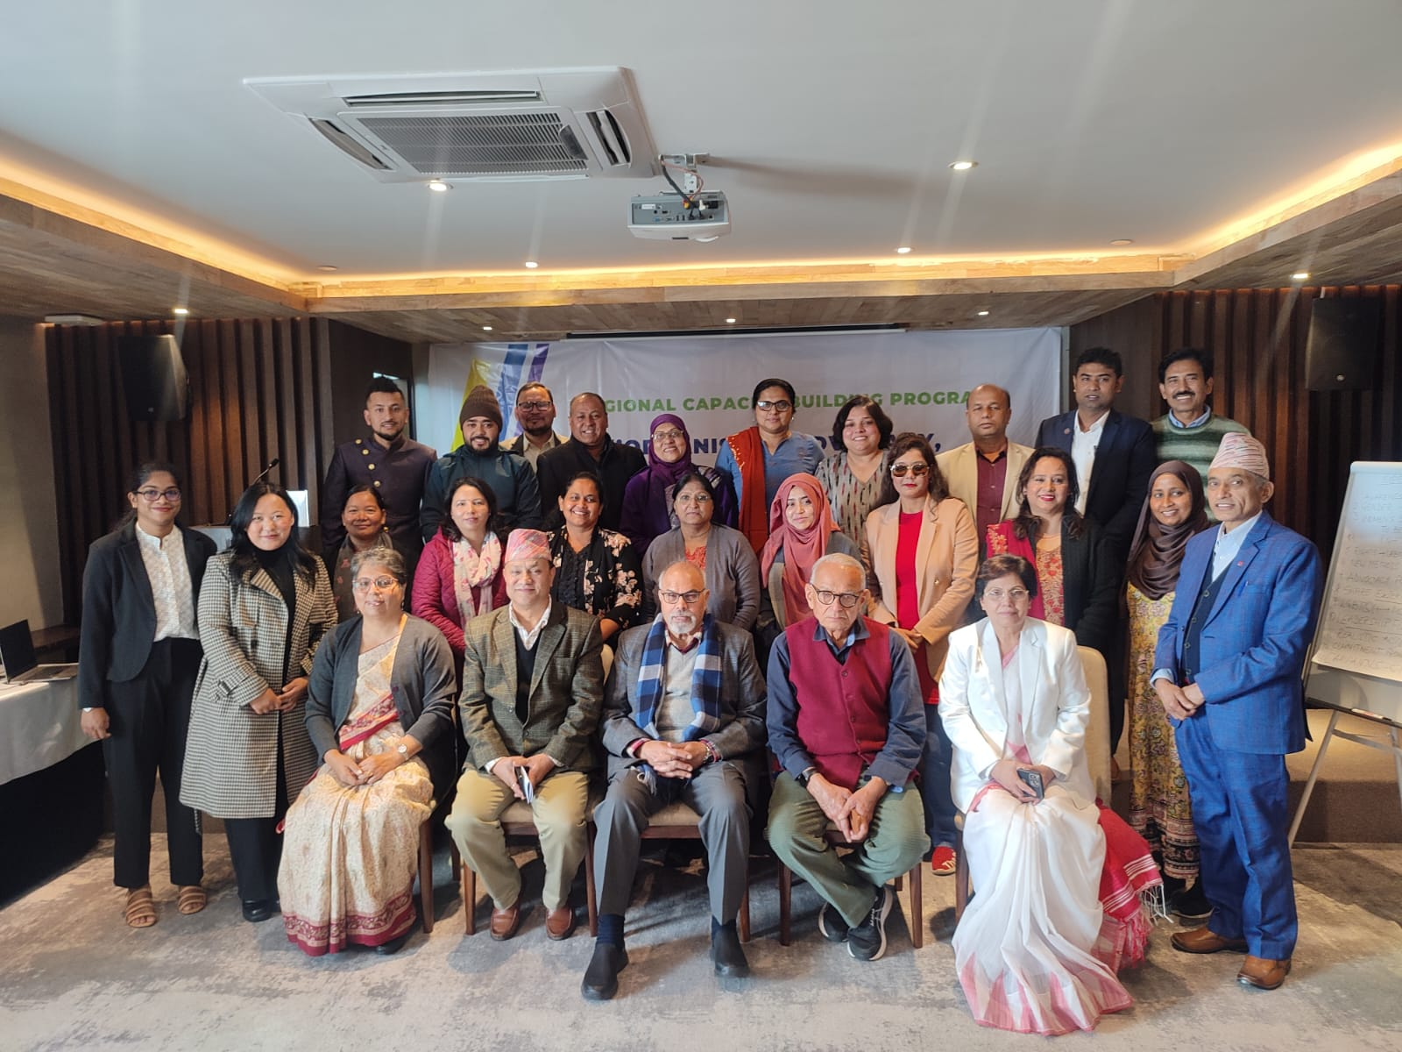

## Background

Gender equality and the empowerment of women are not just moral imperatives but also critical factors in reaching the Sustainable Development Goals (SDGs). While women play a vital role in community and national development, they face challenges such as underrepresentation in leadership and exclusion from decision-making processes. Factors like patriarchy, gender discrimination, limited access to education and resources, and cultural norms contribute to this disparity. Capacity building for women is essential to overcome these obstacles and unlock their full potential. Enhancing women's organizing, advocacy, negotiation, and leadership skills is key to making them effective advocates for themselves and their trade unions, allowing them to actively shape policies promoting gender equality. Despite historical contributions, women in many countries, especially in South Asia, still encounter barriers in labour movements, limiting their involvement in leadership roles and rights advocacy due to unequal power dynamics and societal norms. Genuine gender equality in the workplace and within trade unions remains a challenge.

Given the complex challenges faced by women in South Asia, there is a clear need for capacity-building initiatives to empower women with the skills and knowledge required to navigate these barriers effectively. Strengthening women's leadership, advocacy, negotiation, and organising skills is essential to addressing gender inequality and advancing women's rights in the region. It is thus the time that the SARTUC women's committee takes the lead in the region to advance the organising, advocacy, negotiation, and leadership skills of women to reach the grassroots level, especially in the informal economy and domestic work in the world of work. This will eventually increase women’s participation in trade unions through organising, advocacy, negotiation, and leadership skills. Therefore, SARTUC in collaboration with SAGP and FNV Mondiaal, Netherlands, conducted two days of “*Regional Capacity Building on Organising, Advocacy, Negotiation, Campaigning and Leadership Skills in Trade Unions in South Asia*”, on 12-13 December 2023, at Kathmandu, Nepal (Hotel Barahi Kathmandu, Thamel, Kathmandu).

## Objectives

* To enhance leadership skills, and provide the tools and knowledge for effective advocacy, including strengthening the negotiation techniques for women trade union leaders from SARTUC affiliates;
* To capacitate the organizing skills of the SARTUC affiliates leaders, importantly, women trade union leaders to encourage more women participation in the trade union movement;
* To interact and discuss the role of women as well as transpersons in the trade union movement in South Asia;
* To plan and launch gender equality campaigns for workers and unions;
* To update and form a new SARTUC women’s committee for the inclusion of women in the regional trade union platform.

## Day 1

The **Regional Capacity Building Programme on Organising, Advocacy, Negotiation and Leadership skills in Trade Unions in South Asia** was held under the SARTUC Banner on 12-13 December 2023 in Kathmandu Nepal. 28 participants (16 women; 10 men; and 2 from the LGBTIQ+ community) from Bangladesh, India Nepal, Maldives, Pakistan and Sri Lanka participated. Among the participants there was also a member of the LGBTQI+ community. The programme was formally inaugurated by **Brother Laxman Basnet**, General Secretary, SARTUC and **Brother Yogendra Kunwar**, President of the NTUC, Nepal. Brother Laxman Basnet, General Secretary, SARTUC welcomed and thanked all the participants to the regional programme. He highlighted the importance of gender equality in trade unions and also expressed efforts and activities shall be continued by the SARTUC affiliates at the national and ground because they are the ones who directly work at the national level. He also emphasised the need for more women’s participation in leadership roles in trade unions, thus, they have to take responsibility to step forward the regional cooperation of trade unions and workers. Furthermore, he expressed that gender equality means not only men and women in the workplace but also for the inclusion of the LGBTIQ+ community in the workplace. Finally, he emphasised the constitutional process for the SARTUC’s Women’s Committee and the adoption of ToR. Brother Yogendra Kunwar, President of the NTUC, Nepal, welcomed all the participants on behalf of the host country. He highlighted the necessity of gender equality and importance of the organising, advocacy, negotiation and leadership skills in trade unions in South Asia.

After the formal introduction of the participants, Ms. Nishi Kapahi introduced the **South Asia Gender Platform** to the participants and the work done so far. She also introduced the subject of **Gender Equality in the world of Work**. This was followed by a talk by Mr Sunil Babu Pant, former Member of CA and Parliament of Nepal who is also the founder of the Blue Diamond Society of Nepal which is a non-government organisation for the LGBTQI+ community. Mr. Pant introduced the **LGBTQI+** community to the participants, most of whom were not familiar with the community. His talk was an eye-opener for many (The presentation of Ms. Nishi Kapahi and Mr Sunil Babu Pant are attached).

The participants presented their **country reports** which included information on the union activities and the policies on women’s rights adopted by the unions. Unions mostly claimed to have verbal policies with only a few having written ones. None of the unions have an Equal Opportunity policy. The session was moderated by Mr Mahendra Sharma, Advisor SARTUC. The country reports presented by the participants are attached.

## Major points presented in the country reports

**Bangladesh**

* 53 per cent of women; 47 per cent of men;
* Ratify C-190;
* Social Dialogue;
* Awareness at all levels;
* 63.5 million – Total employment; 43.5 million – men; and 20million women;
* Garment – 86 per cent of women and 14 per cent of men.

**India**

* Total 1.43 billion population
* 28 per cent of women in the workforce
* No women in decision-making in trade unions, however, SEWA is a women-only union in India.
* LGBTIQ+ - not in priority
* Awareness
* Increased – women's participation in the workplace
* Informal economy

**Maldives**

* The total population is around 500,000 where around 82,000 are natives.
* Huge number of migrant workers.
* Male – Construction
* The influx of Sri Lankan
* Free education
* Compulsory education
* More girls in higher education
* 33 per cent of women
* GDP: Tourism and fishing
* 65 per cent of women in the public sector
* Equal pay
* Single parent allowance

**Nepal**

* Women - Vice President in trade unions
* Elected central women's committee body
* 33 per cent representation in committees at all levels.
* Separate regulation for women in trade unions.
* Gender audit
* Regulation for women
* Equal pay
* Training and orientations at the workplace
* Discussion and training on C190 at the workplace
* Ratification of C190
* CBA- Women’s participation
* 33 per cent of male participation in women’s programme
* Gender parity

**Pakistan**

* Gender discrimination
* 51 per cent of men; and 19 per cent of women.
* Union membership: male – 80 per cent; female: 20 per cent.
* Women drop-out from schools is high.
* High discrimination
* Need more financial inclusion
* Gender policy
* Ratification of C190.

**Sri Lanka**

* Plantation sector – more women
* Long working hours
* Women – more educated
* Violence and harassment
* Women members are 62 per cent and women general secretary in the Ceylon Workers’ Congress (CWC), one of the trade unions in Sri Lanka.
* Sri Lanka Nidahas Sevaka Sangamaya (SLNSS) – migrant workers
* Ratification of C190
* ILO provides training and orientation in OSH in the plantation and garment sectors.
* Restrooms are very important in the workplace, more importantly in the plantation sector.

## Day 2

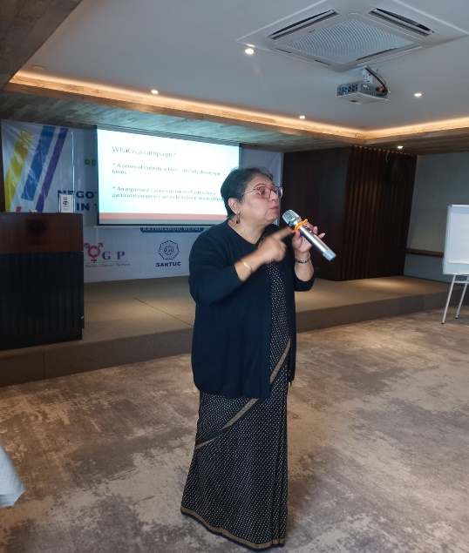On Day 2, a session on **Gender Equality and Social Dialogue** was organised with a presentation by Mr Soloman Rajbanshi, Senior Programme Officer, ILO country office, Nepal, making a presentation. His presentation is attached for ready reference.

Mr. Mahendra Sharma then conducted a session on **Advocacy and Negotiation skills** for women trade union leaders in South Asia. He spoke about the importance of engaging women in negotiations and the use of technologies for advocacy in the changing world of work.

This was followed by a presentation by Sister Paba Deshapriya who had drafted the **draft Equal Opportunities Act** for Sri Lanka, who introduced the document through a video presentation as she could not be physically present in Kathmandu. The document was discussed with the participants who said they would like to further discuss the same with their leadership and the other unions within their respective countries before taking a call on its adoption. It may be mentioned here that this draft was already discussed by the participants and some leaders who were present in Colombo on 01-02 February 2023 during the SAGP Seminar held there. The participants will send us their feedback. It was also decided to once again share the documents with the leaders of all participating unions so that they are in line with this Act and are in a position to lobby with their respective governments and/or employers/management for the adoption of a policy document for their country.

Ms. Nishi Kapahi introduced the subject of **campaigns** to the participants which will form the basis of the Gender Activities in the current phase of Gender Platform. To take the discussion forward, the participants were asked to plan the campaigns that they and their unions would lead in the coming months. The idea of showcasing their work on the campaigns during the forthcoming **World Social Forum (WSF)** was also discussed. The groups after working on their campaigns agreed unanimously to work on the issue of **Equal Opportunities for All** and addressed the various challenges being faced within their countries under this topic. The WSF is being held in Kathmandu Nepal from 15-19 February 2024 where the trade unions including SARTUC will be putting up their stalls and conducting other activities and talks. South Asia Gender Platform along with the participating unions under the banner of SARTUC will also showcase their campaign demanding Equal Opportunities for All.

Ms. Nishi Kapahi shared the plan of action for the forthcoming WSF with the participants and explained the assistance that they would receive from SARTUC for running their campaigns. She also mentioned the lack of resources with SARTUC due to which financial assistance would not be possible, however, assistance in terms of material, the launch of online portals for them to share their photos and videos would be provided. She said the SARTUC secretariat would also be sending them the designs, posters, logos which could be used by them in their local language to enable them to reach out to the grassroots workers as well.

## Topics/Issues decided or agreed to run campaign

The Campaign needs to be focused on **Gender Equality** and **Equal Opportunities for All**.

**Themes:**

1. Women in decision-making level and Leadership - breaking the glass ceilings and walls.
2. Break Stereotypes (posters and messages with images can be used).
3. Clearly spell our demands of women - Eliminating violence/harassment/bullying
4. Need for sensitization - at the workplace (related to issues of women and LGBTQI+)
5. Safe spaces for women (C190).
6. Dignity and Respect for all Gender (ILGBTQI+ communities too)
7. Ratification of Cl11 and C190.
8. Equality in terms of pay/wages/conditions of work.
9. Health and Safety (OSH).
10. Internal complaint committee at all levels (space spaces) just for India. Legal requirement with more than 10 people working. SPACE SPACES FOR ALL. (ICC)

**Hashtags**

1. #equaliopportunityforall
2. #SAYNOTODISCRIMINATION
3. #RATIFYC190
4. #RATIFYC111
5. #SARTUC
6. #GENDERPLATFORM
7. #SAGP
8. #SAFESPACEFORWORK
9. #LQBTQI
10. More can be added according to the posts

## Conclusion

* The programme then ended with an evaluation from the participants.
* Everyone agreed to run a campaign on Gender Equality/Equal Opportunity for All, participants, the SARTUC Women’s Committee, and all the SARTUC affiliates will support and provide the required materials for the campaign.
* At the end of the programme, a meeting was held to establish the Women’s Committee of SARTUC which comprised of one member from each country. The Pakistan representative was elected the Chair while Bangladesh and Nepal will share the position rotationally for a period of two years each.
* SEWA’s Sonia George will be the Technical Advisor to the Committee.

## Decisions from SARTUC’s Women's Committee

* Ms. Dur e Shawar (Pakistan) has been elected as the Chair for the SARTUC Women’s Committee. (for the first two years);
* Ms. Mousumi Nishat Shimul (Bangladesh) has been elected as the Vice Chair for the SARTUC Women’s Committee for the first two years;
* Ms. Sushila Ghimire (Nepal) has been elected as the Vice Chair for the SARTUC Women’s Committee for the second term of two years;
* Once India sends a name for the women’s committee, she will be a member of the Committee;
* Regular Zoom meetings would be done for updates on the work done and new programme discussions.

**Annex-I**

**SARTUC’s Women's Committee**

|  |  |  |  |
| --- | --- | --- | --- |
| **SN** | **County** | **Committee Member Names** | **Designation** |
| 1 | Pakistan | Dur e Shawar | Chair |
| 2 | Bangladesh | Mousumi Nishat Shimul | Vice Chair |
| 3 | Afghanistan | ………………………………. | Member |
| 4 | India | ………………………………. | Member |
| 5 | Maldives | Fathimath Zimna | Member |
| 6 | Nepal | Sushila Ghimire | Member |
| 7 | Sri Lanka | Chandrani Panditha | Member |

**Annex-II**

**Participants List**

|  |  |  |  |
| --- | --- | --- | --- |
| **S.N** | **Country** | **Name** | **Organization** |
| 1 | Bangladesh | Mr. MD Abdul Gofur | BJSD |
| 2 | Ms. Syeda Azizun Nahar | BLF |
| 3 | Ms. Ajija Sultana | JSL |
| 4 | Mr. Shah Newaz Khandaker | BFTUC |
| 5 | Ms. Mousumi Nishat Shimul | BMSF |
| 6 | Mr. Kazi Riyadh | BSSF |
| 7 | India | Ms. Sonia George | SEWA |
| 8 | Ms. Nishi Kapahi | SAGP |
| 9 | Mr. Mahendra Sharma | Advisor, SARTUC |
| 10 | Ms. Champa Verma | HMS |
| 11 | Ms. Umanagendramani Makaraju | INTUC |
| 12 | Maldives | Ms. Fathimath Zimna | MTUC |
| 13 | Pakistan | Ms. Dur-E-Shawar Shiraj | PWF |
| 14 | Sri Lanka | Ms. Chandrani Panditha | SLNSS |
| 16 | Ms. Kanishta Michael | CWC |
| 17 | Nepal | Ms. Anju Agasti | ANTUF |
| 18 | Mr. Subash Dhakal |
| 19 | Ms. Beli Maiya Ghale | GEFONT |
| 20 | Mr.Naranath Luitel |
| 21 | Ms. Sushila Ghimire | NTUC |
| 22 | Mr. Bishnu Khadka |
| 23 | Mr. Surendra Pandey | LGBTIQ+ Community |
| 24 | Mr. Sunil Babu Pant | Resource Person |
| 25 | Mr. Saloman Rajbanshi | ILO Nepal |
| 26 | Mr. Laxman Basnet | SARTUC |
| 27 | Mr. Kishor Bikram Shah |
| 28 | Ms. Sweanta Lama |

**Annex-III**

**Agenda on**

**Regional Capacity Building Programme on Organising, Advocacy, Negotiation, and Leadership Skills in Trade Unions in South Asia**

|  |  |  |
| --- | --- | --- |
| **Day 1: 12 December 2023 (Tuesday)** | | |
| 9:00 – 9:30 | Registration | |
| 9:30 – 9:40 | **Opening**  Opening and welcome address: **Mr Laxman Basnet**, General Secretary, SARTUC | |
| 9:40 – 9:50 | Overview of the Regional Capacity Building Programme | **Ms. Nishi Kapahi,** Coordinator, SAGP |
| 9:50 – 10:15 | Introduction and Expectations of Participants | **SARTUC** |
| 10:15 – 10:25 | Group photo | |
| 10:25 – 10:45 | **Tea/Coffee Break** | |
| 10:45 – 11:30 | Introduction to the South Asia Gender Platform  Gender Equality in the World of Work | **Ms. Nishi Kapahi,** Coordinator, SAGP |
| 11:30 – 12:45 | An Introduction to the LGBTIQ+ Community and Equal Opportunity in the World of Work | **Mr. Sunil Babu Pant,** Former Member of CA and parliament, and Founder, Blue Diamond Society |
| 12:45 - 13:45 | **Lunch Break** | |
| 13:45 – 14:45 | **Country reports** about the union activities and policies on Women’s rights and women’s participation in the trade union movement  Country-wise discussion  (*Creative presentation by the participant: Participants shall prepare this in advance focusing on key accomplishments/changes made*)  **Presentation of country reports**  (*Max. 10 minutes each presentation)* | **Mr. Mahanedra Sharma,** Advisor, SARTUC |
| 14:45 – 16:00 | **Equal Opportunity Act**   * Participants have to create advocacy and campaign materials in groups (photos, posters, pamphlets, art, videos, etc.). * This session allows participants to share their thoughts on how to create and run the best campaign possible   (*ratification of C189, C190, and others related to women’s rights in the world of work*) | **Ms. Nishi Kapahi,** Coordinator, SAGP |
| 16:00 – 16:15 | **Tea/Coffee Break** | |
| 16:15 – 17:00 | Planning need based campaigns | **Ms. Nishi Kapahi,** Coordinator, SAGP |
| **End of Day 1** | | |
| **Day 2: 13 December 2023 (Wednesday)** | | |
| 9:00– 9:15 | Registration | |
| 9:15 – 10:00 | Recognizing Social Dialogue as a governance tool for the promotion of equality between Genders in the world of work | **Mr. Saloman Rajbanshi,** ILO Country Office for Nepal |
| 10:00 – 11:15 | **Advocacy and Negotiation skills for women trade union leaders in South Asia**   * Engaging in negotiations * Advocacy through the use of technologies in the changing world of work | **Mr. Mahanedra Sharma,** Advisor, SARTUC |
| 11:15 – 11:30 | **Tea/Coffee Break** | |
| 11:30 – 12:20 | **Group work**   * Strategies for organising women workers to protect worker’s rights in the world of work * Strategies to increase the number of women workers and leaders in trade unions * Challenges for women in the World of work, including the digital world * South Asian Women’s Journey to Workplace Leadership: experience and example | **Ms. Nishi Kapahi,** Coordinator, SAGP |
| 12:20 – 13:00 | **Presentation by groups** | |
| 13:00 – 14:00 | **Lunch** | |
| 14:00 - 14:30 | Formation of a **SARTUC Women’s Committee** | |
| 14:30 - 15:00 | **Plan of action for the next 4 years** to SARTUC Women’s Committee (Priority Areas) | |
| 15:00 - 15:30 | Presentation | |
| 15:30 – 15:40 | Closing remarks and vote of thanks  by **Mr. Laxman Basnet**, General Secretary, SARTUC | |
| **End of the capacity-building** | | |

**Annex-IV**

**Photos**

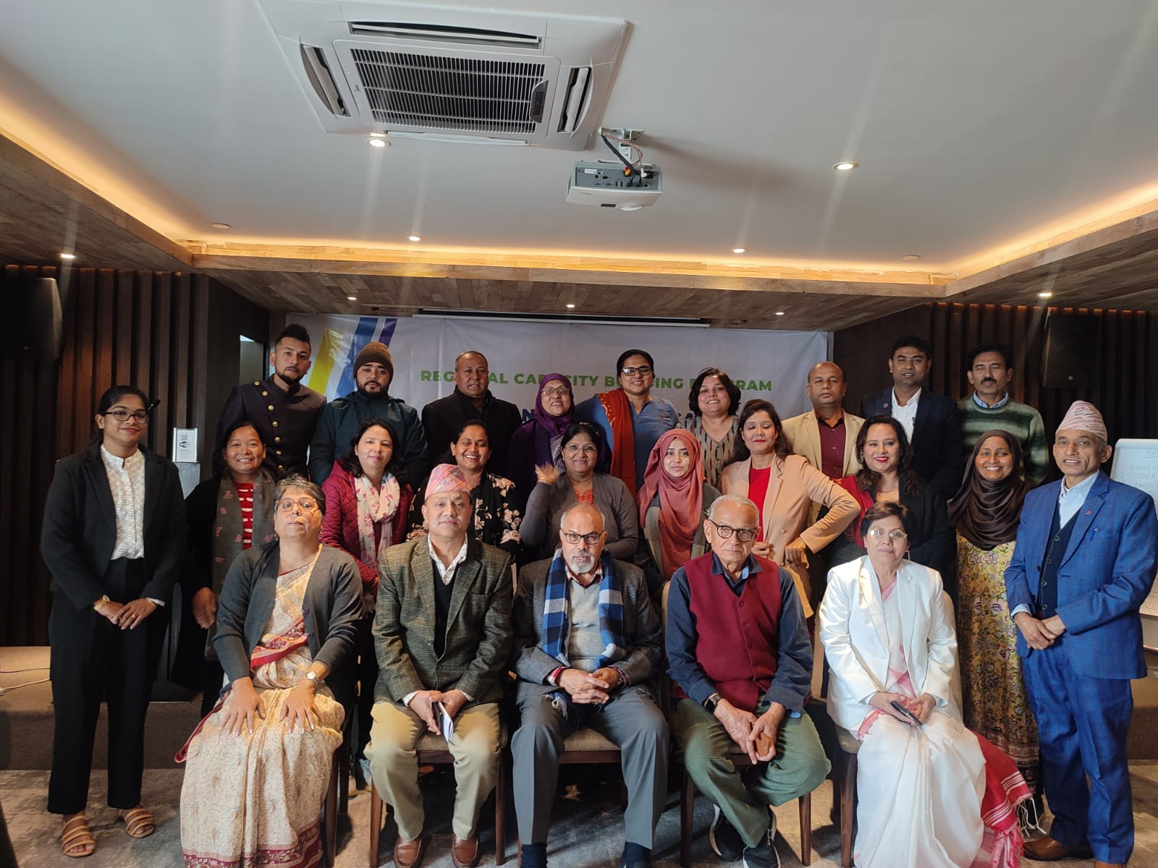

**Group Photo**

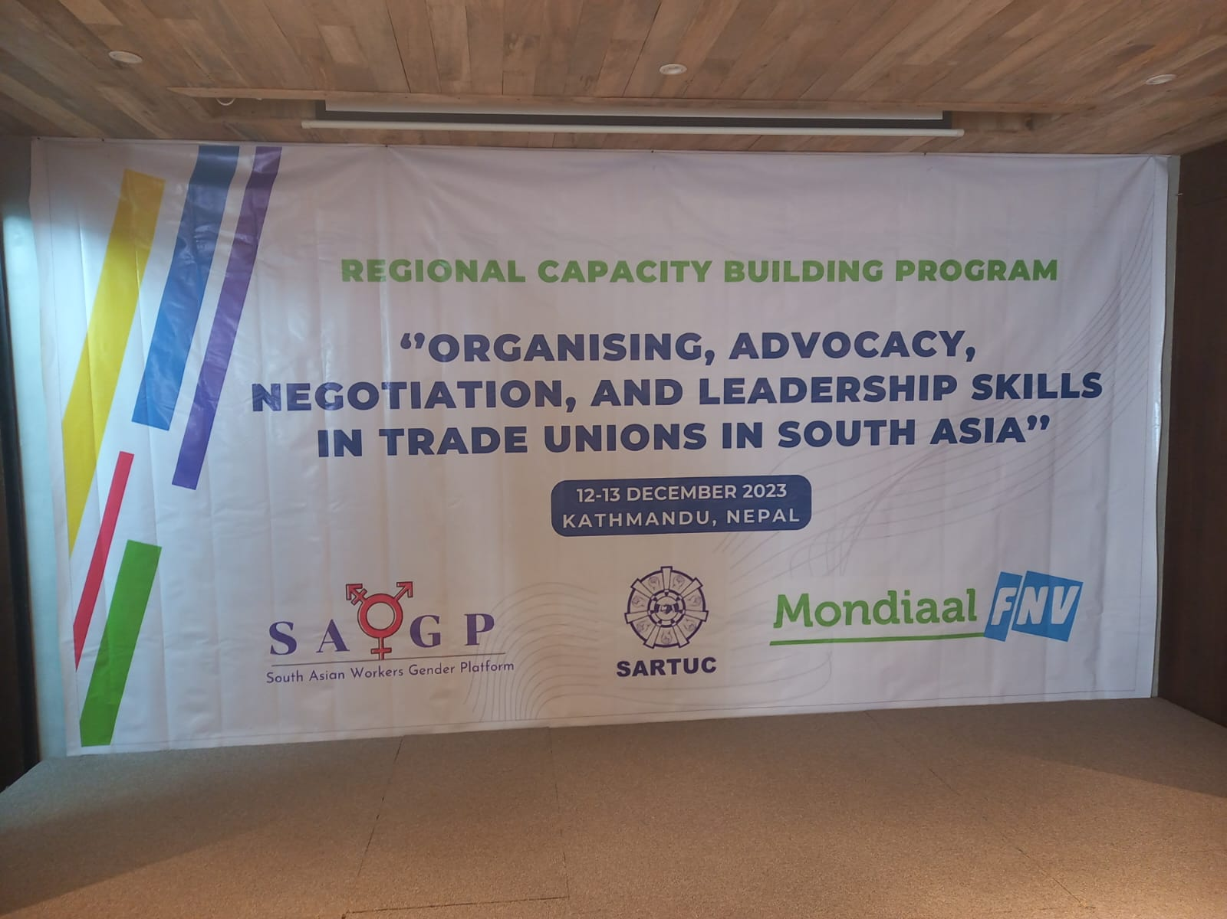 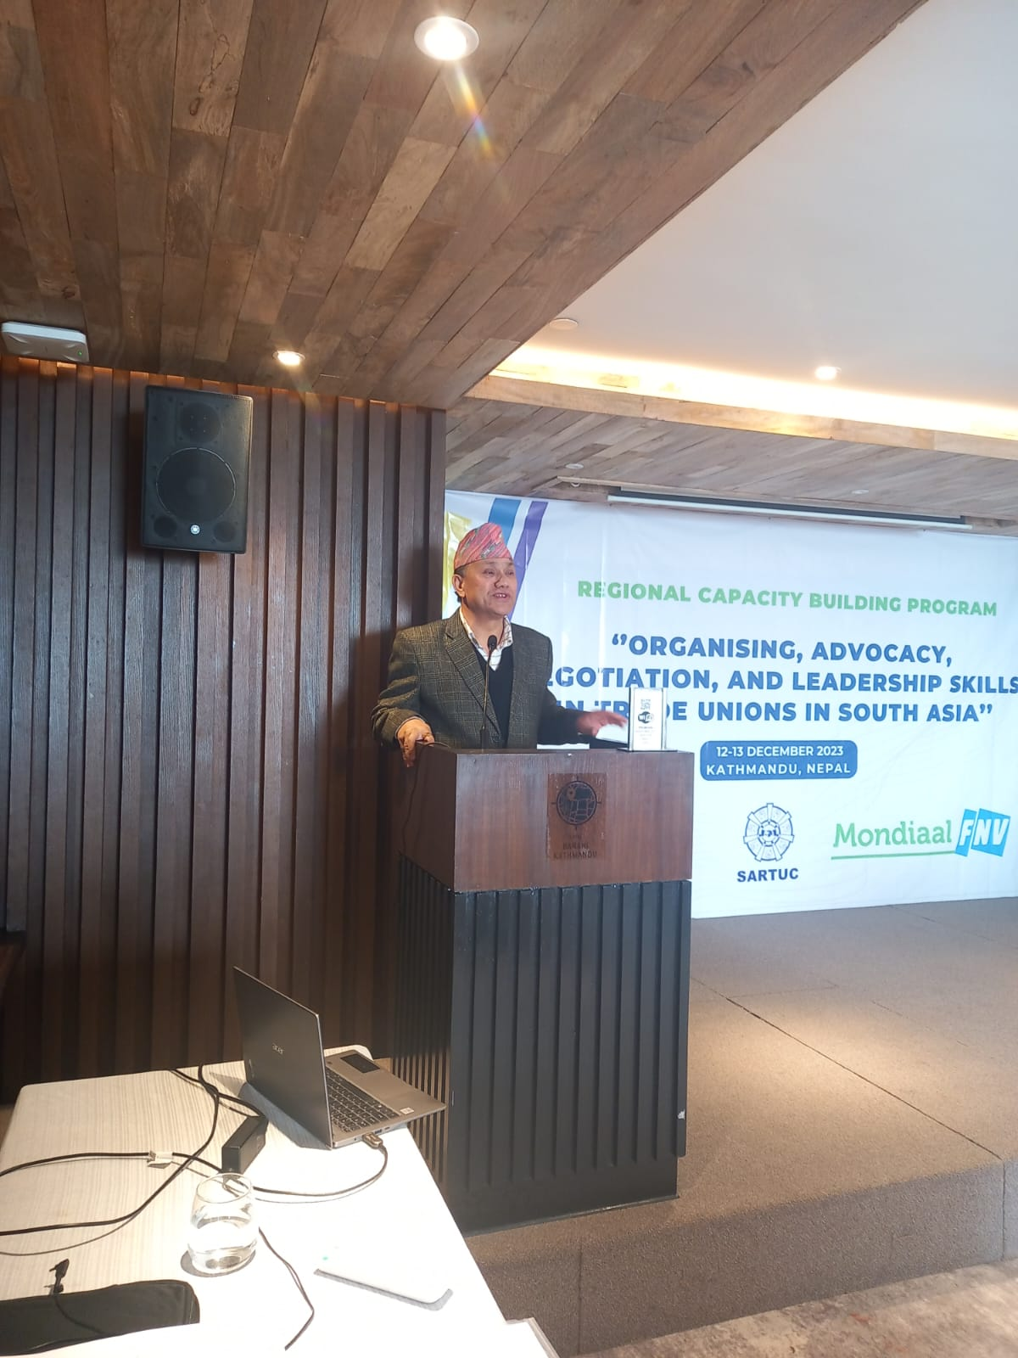

**Mr. Yogendra Kunwar**, President, NTUC, delivering his welcome remarks.

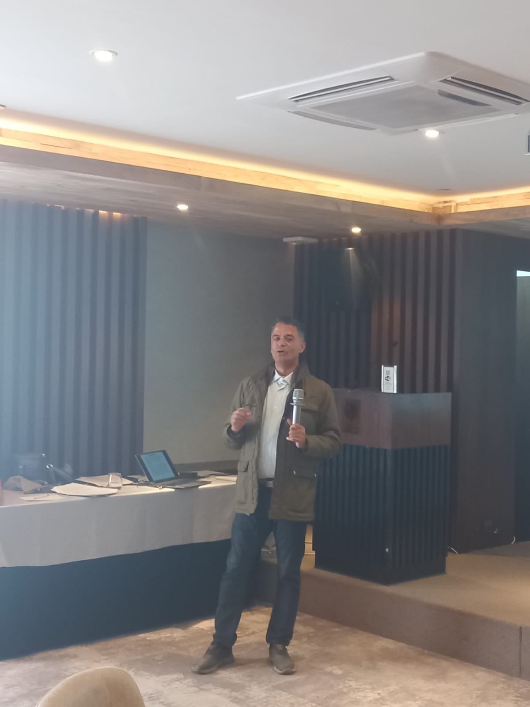 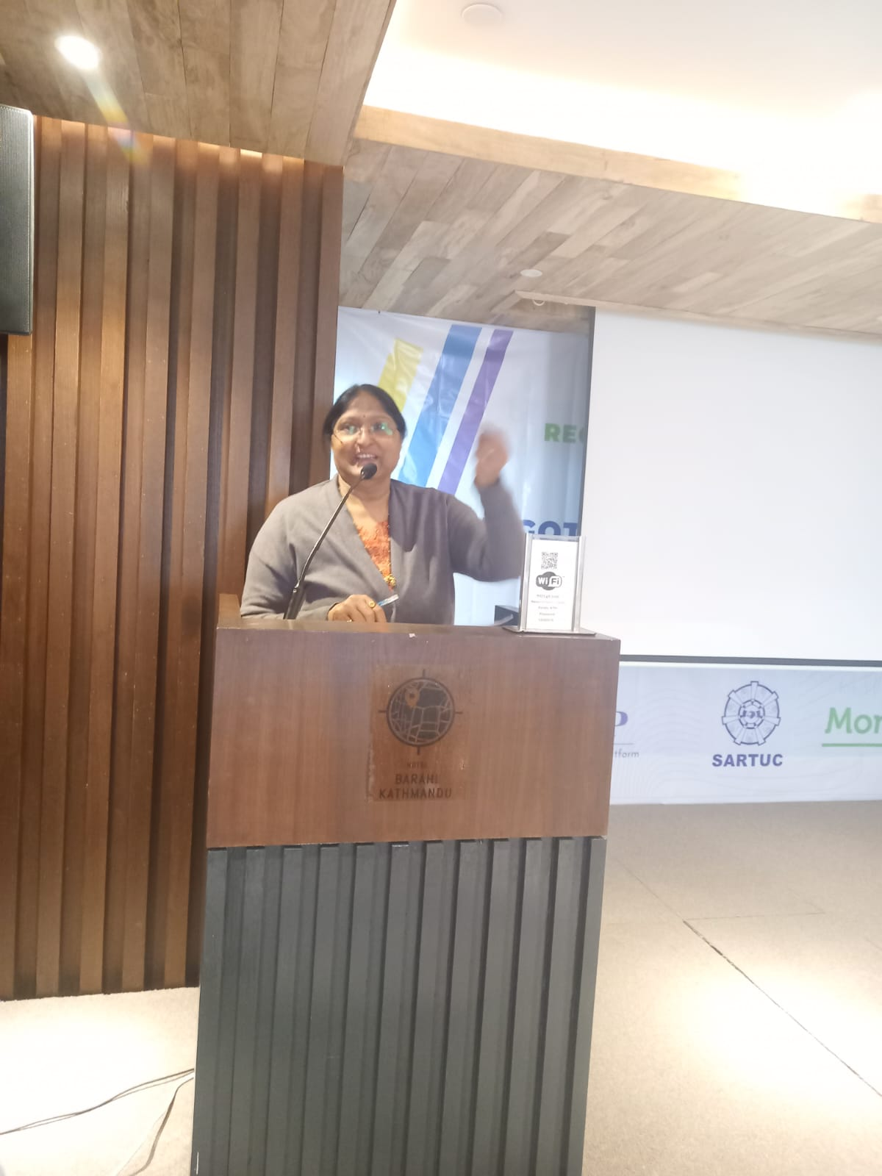

**Mr. Sunil Babu Pant**, Former Member of CA and parliament, and Founder, Blue Diamond Society, is conducting session on “*the LGBTIQ+ Community and Equal Opportunity in the World of Work*.”

**Ms. Umanagendramani Makaraju**, INTUC and Women Secretary of SARTUC - presenting a country report from India.

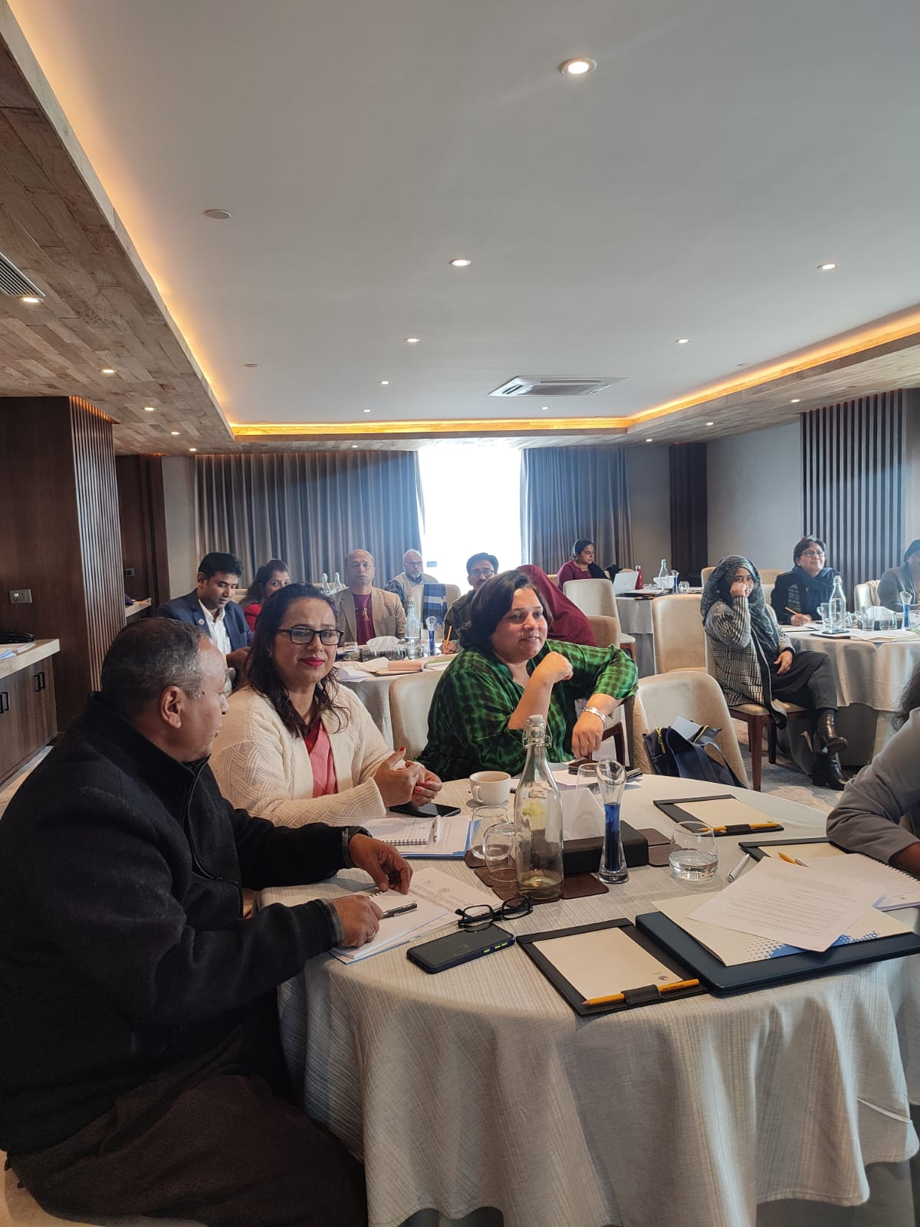 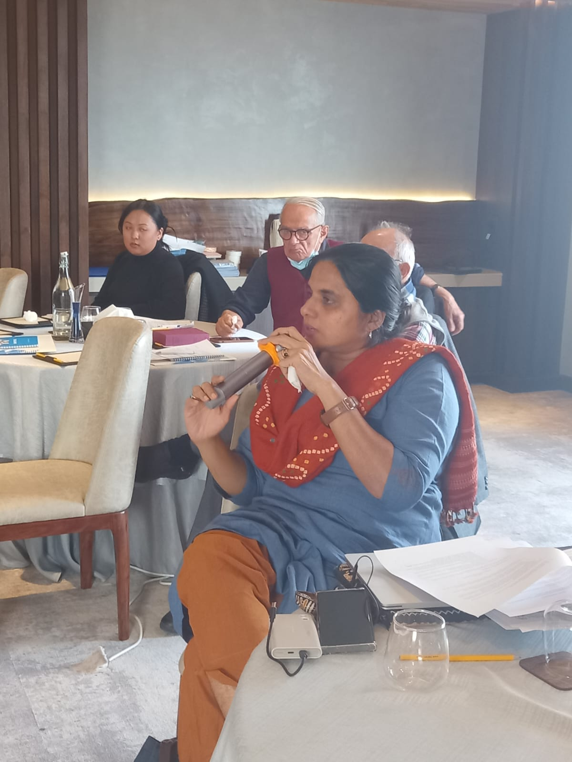

**Ms Sonia Geroge**, Chair, Technical Committee for Programme, SARTUC, expressing her views on the situation of women’s leaderships in Trade Unions in South Asia.

Participants attending Session.